Joseph Roper

Salford City College | [Company address]

BTEC National 90 Credit Diploma in Creative Media Production

Unit 1: Pre-production techniques

Contents

Types of production 2

Time Issues 4

Personnel 4

Financial Issues 5

Facilities 6

Materials 7

Contributors 7

Location 9

Codes of Practice 9

Sources 12

Industry Issues

# Types of production

Media production has many different genres such as television, movies, gaming, radio and social media. Movies are regarded as the most expensive forms of media out of this list as people believe the more you spend on a movie the better it will be and sell. The reason movies usually have such a big budget is because all the equipment needed such as: a camera so let's go with a Panasonic GH4 (4K), a tripod, camera light, three-point lighting kit, a shotgun microphone so let's say an Audio-Technica AT897 and bunch of other equipment but already that racks up an estimated cost of £1150 and that just for a student level film. An example of a movie success is the first movie of its series which spawned 5 others, also known as Rocky because it costed $1,000,000 to make and earned a grand total of $225,000,000.

An example of a movie couple, a failure and a success are from the movie series Kingsman. The first Kingsman film Kingsman: The Secret Service was a great success as the production budget was $94,000,000 and it earned a stunning total of $404,561,724 in the worldwide box office. Although when success comes, failure arrives shortly after with Kingsman: The Golden Circle the sequel to the first, it costed 20th Century Fox and Marv Films $104,000,000 to make and it earned a depressing total of $256,496,660 compared to the original film. A big reason for its failure is because the team behind it did not realise what made the first film so enjoyable, this is because they didn’t ask what the audience truly liked about the film and just saw their reactions to the actions scenes and thought that was what made the first film so good, so in the sequel they added a bunch of actions scenes which were all the same with no stakes or difference without adding the story and relationships between the character and the viewer for them to care enough if characters died in the movie. From this I learnt that when producing a sequel of anything ask the fans what truly made the product good or ask critics then I would take that response and make the next one better with the feedback received.

[](https://store.hmv.com/film-tv/dvd/kingsman-the-secret-service)[](https://en.wikipedia.org/wiki/Kingsman:_The_Golden_Circle)

Gaming or video games are a recent form of media production as it became popular around the 1980s with the release of the Nintendo Entertainment System or as it's more commonly known the NES. Before the NES the market for gaming was at risk of crashing as developers were just constantly spitting out clones of terrible games and raising the prices meaning no one bought these games and no customers, means no money. An example of a video game failure is with the game No Man's Sky, the reason for its failure was because they basically lied to the public about what the gameplay of the game really was as the developers marketed the game as a fun vast open world with lots of surprises and fans believed this as it was their only sources of information about the game as they showed hardly any gameplay and a bunch of trailers including cutscenes what were not in the game and didn't even look like the gameplay. This means that when the game was released to the public and fans played it they were deeply disappointed as the game was open world but wasn’t fun as the only thing their character could really do was shoot a beam to collect resources which were useless. This resulted in players wanting full refunds and No Man’s Sky eventually fell along with the developers behind it never really to be trusted with making a game again.

[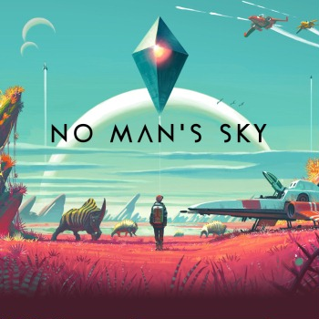](https://en.wikipedia.org/wiki/No_Man%27s_Sky) [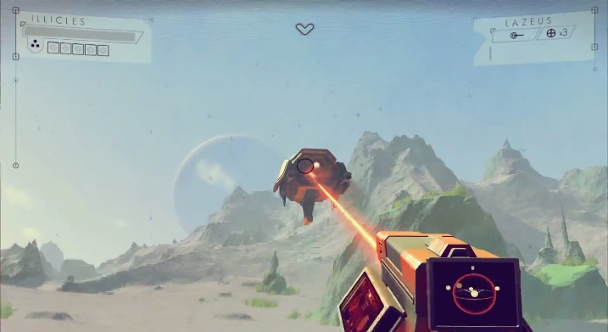](https://wallpapersafari.com/no-mans-sky-hd-wallpaper/)

Triple A (AAA) games are usually expensive as the company funding the game want it to be better than the rest resulting in a massive profit. While games do need a lot of money to fund the game, high budgets don't mean everything. This concept is shown when the games Call of Duty: Modern Warfare 2 and GTA V (5) are compared as Modern Warfare 2 costed $250 million to make and made over $1 billion overall, whereas GTA 5 costed $265 million to make and roughly made $2 billion overall in profit. From this I have learnt to have a big budget for a game while useful doesn’t instantly make a game a hit seller making a lot of profit, and that it is the gameplay and the work put into a game like including free updates will make the game enjoyable and popular receiving a bigger profit.

[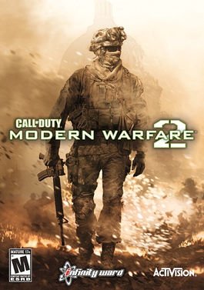](https://en.wikipedia.org/wiki/Call_of_Duty:_Modern_Warfare_2) [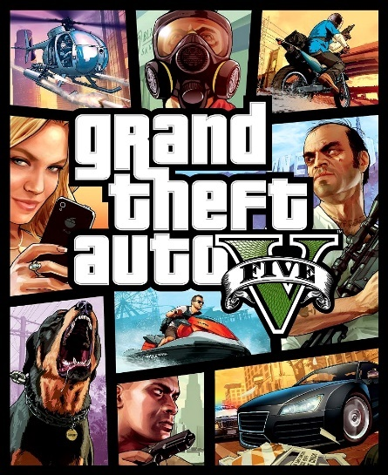](http://gta.wikia.com/wiki/Grand_Theft_Auto_V)

# Time Issues

Time is useful and important everywhere in life but especially during the pre-production of a game as it is used; to set deadlines, for scheduling and milestones. Deadlines while mostly being hated by game developers are useful as they provide a target for them and if the deadline provides the team with the time necessary to complete the task the pre-production of the game will run smoothly, and the team won’t be hindered in the future. Whereas if the deadline set by the project manager/lead developer is unforgiving and nearly impossible to provide suitable work the game will most likely fail and will be riddled with bugs when the game is eventually released as the development team would have had to spend more time on making up for the work the team wasn’t able to do leaving no time for bug tests. Scheduling is when you set out a plan for when you should have completed different tasks of a project and when you should be working on other tasks and usually contains information such as who is working on them and who is the manager of that separate team. Schedules allow for confusion to be eliminated in the workplace. If a team sticks to a schedule the project will be completed on time and too a good standard.

An example of a game which experienced many time issues while in development is Mass Effect Andromeda which was not well received by fans when released this was because while in development the team never had a clear schedule and any other deadlines than the final one meaning the team was always far behind on their work so when it came to release the game had not been properly tested due to time constraints  meaning the player experienced many but through the playthrough of the game meaning it was a fail in the gaming industry and nearly killed the Mass Effect franchise. From this example I have learnt that before development starts for a game a clear and correct schedule should be made which includes deadlines other than the final one to be on their such as for when game testing should start, this will make it, so workers will know when they should be finishing projects and starting new ones.

[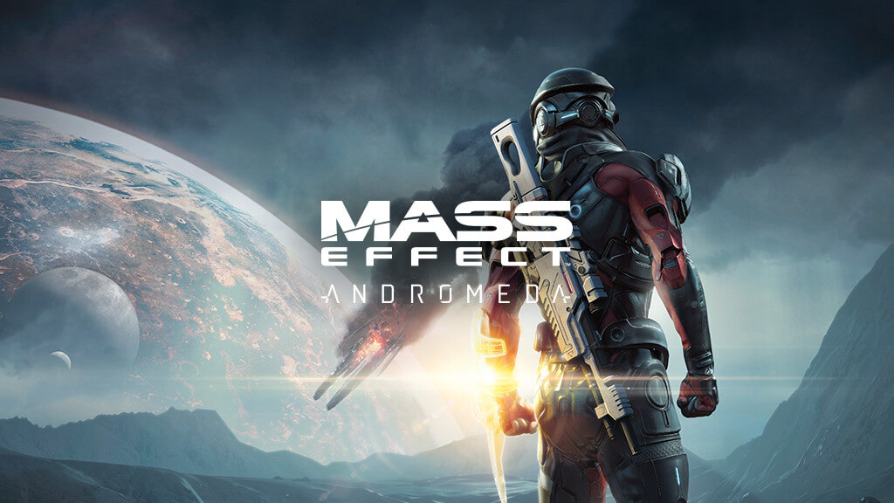](http://www.animstate.com/round-table-mass-effect-andromeda/)

# Personnel

Personnel is also very important while producing a game as it is used to motivate development teams, so they work harder and better than usual. Personnel manages the size of a team, who should be in a team while considering relationships between co-workers, who is right fit for different tasks and finally they solve disputes between the workplace. When personnel work one of the first tasks they do is look at the different teams and consider their size, also they figure out how many staff are needed to manage the workplace. Then personnel will try and make it so there is at least more than one person with the same skillset so if one is sick the other can step up and do their work as well, however this is not suitable for small or low budget teams as they won’t be able to afford an abundance of recruits. Personnel usually cover the hiring process and will either look for people with the best skill set, experience and passion for the role entailed. Although personnel would also consider hiring someone who isn’t that well qualified which could then be trained to fit the skillset required personnel consider this as they will be able to pay the unqualified recruit less than the qualified recruit this will also make the unqualified recruit loyal to the company however this would slow down work as you will have to teach the unqualified recruit.

An example of a game that failed because of personnel issues is [Aliens: Colonial Marines](https://kotaku.com/5986694/from-dream-to-disaster-the-story-of-aliens-colonial-marines)

The reason this game failed is because every person working on the game had conflicting views for the games direction as one wanted it to look and play like the infamous franchise Call of Duty but the project managers disagreed as they wanted the player to shoot aliens not people, there were also other issues such as when Gearbox known for the Borderlands series was working on the game for roughly 3 years they did no work on the game not even a story as their focus was mainly on the sequel for the game Borderlands as it was a success in the gaming industry and made Gearbox a lot of money so of course they want to make another. This meant that when the game was finally given to Time Gate there was nothing to work with, so they had to think up of a story for the game quickly before the deadline set by Sega meaning there was a lot of holes in the story as there were many people on the team who again had different opinions for what they wanted the story to be, resulting in a mess of a game which was obviously a fail from the start. From this I have learnt that cohesion is needed in the workplace and a games development team should always agree when making a crucial decision such as the gameplay and story of a game otherwise it will most likely result in a loss for the company.

[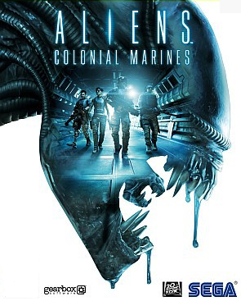](http://store.steampowered.com/agecheck/app/49540/)

# Financial Issues

Finance is everything in business meaning it is important when designing a game because it’s the thing that keeps you running as it funds for workers, equipment, the rent for a workplace and plenty other things. Having a good financial plan when producing a game can is essential as without one you could run out of money in the middle of a project. A financial plan should include the cost of equipment, salaries and the rent for the workspace. A game can be financed by yourself, fundraising, sponsors, bank loans, pre-orders and donations such as from the Website Kickstarter which is a platform that allows people to give creators money for their project an example of a game funded by Kickstarter is the infamous Undertale.

An example of a game that only failed because of financial issues is Homefront The Revolution, the reason for the failure of this game starts with the original publisher for the game being liquidated (they went bankrupt) meaning the team behind it had to find a new publisher causing many workers to leave as they were not getting paid meaning when it came to making the game there was only a small team which had a now small budget, this resulted in corners being cut as the game wasn’t properly tested, so when it was finally released after 4 years of development there were a lot of game breaking bugs which meant the game wasn’t received well with bad review scores. From this I have learnt that having a good financial plan is important and parts of a game's budget should be not be touched and only be used for what they are meant for such as game testing.

[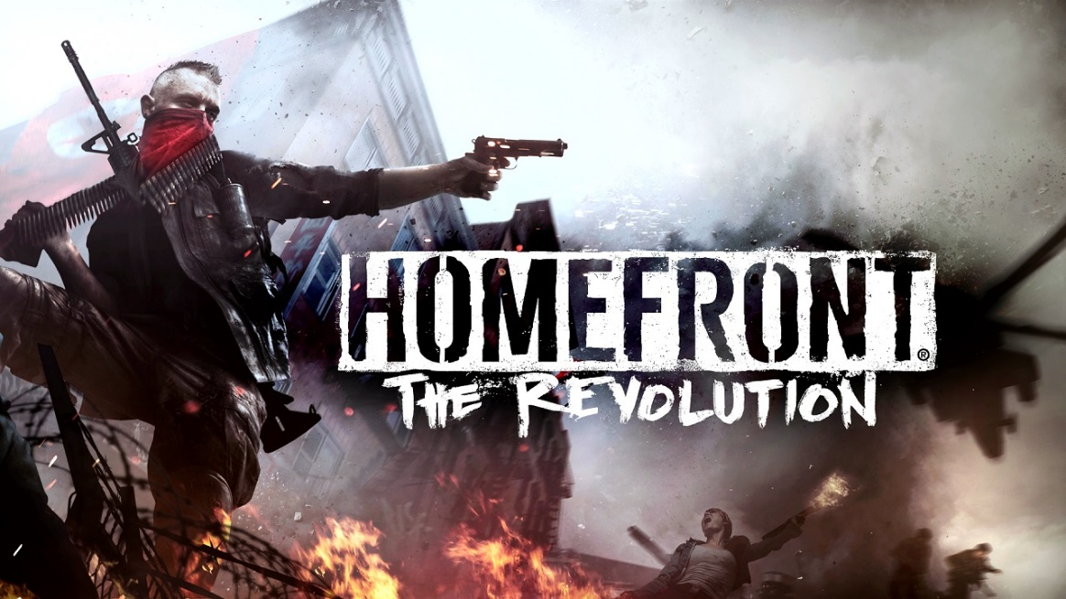](http://oceanofgames.com/homefront-the-revolution-free-download/)

# Facilities

Facilities when designing a game can include: equipment such as computers that are powerful enough to handle rendering 3D objects or even specific software like Construct 2 and Photoshop and space such as an office as is the workplace is too small workers will be cramped together and will be less motivated too work whereas if the space is too big money will be wasted. Facilities can vary between different fields of a business as a television show will have lighting and camera equipment in their building and a recording studio will have expensive microphones, speakers and mixers whereas a game development facility would most likely have these things such as a green screen, motion capture suits and of course expensive computers.

An example of an excellent company with a headquarters containing things perfect for games development is Naughty Dog, as they have powerful computers to render 3D graphics in games, motion capture suits and green screens to record lifelike footage to be implemented in a game. These facilities are needed when making a triple A game such as Uncharted 4 and could not be done well without these things as if Uncharted 4 was made in someone’s bedroom or garage the game would not look as stunning and realistic as it does as the computer would not be powerful enough to make the 3D animation and they wouldn’t be able to do as nearly enough things as they would at Ubisoft so that is why certain facilities in games are important when making a triple A game. From this I have learnt that specific facilities are needed to make well developed games which are lifelike and realistic so if I was to make a game which looks like Uncharted 4 I would need to use budget appropriately by hiring certain facilities out and making good use of them.

[](http://sms.playstation.com/news/time-to-move/) [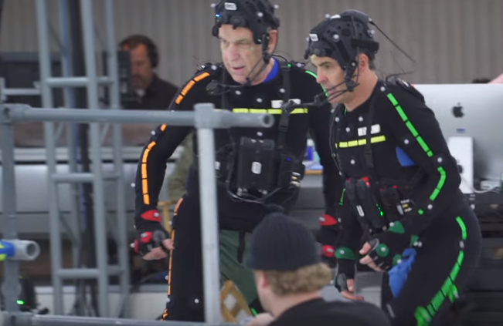](https://www.youtube.com/watch?v=ODPEIUCEp4g)

# Materials

Materials are the things used in development to create the game they can be purchased or rented if they are rented they will need to be added to a schedule, so you use them effectively in the time you have it. Materials can include computers which will usually be bought or previously owned, software such as Photoshop which is rented as you must buy a license for it which usually lasts for a year and motion capture suits which can be rented or bought. When materials need to be rented a priority list should be made so if you need to rent something that is needed to start production of a game that should be at the top of the priority list to get first. In order to make a game certain things are needed such as music sound and graphics so usually developers will buy a sound library containing sounds of punches and other movements or if it is a big game development company they would hire people to use Foley artistry and recreate sound such as footsteps in the snow buy recording the sound of someone walking in sand in a room. Also with graphics, developers would create their own assets like 3D models made by themselves.

An example of a material used in a video game is with the game franchise Destiny, as the producers Bungie used their material which is the composer Martin O'Donnell to make the beautiful soundtrack for both games in the series. Although Martin O’Donnell isn’t a computer of software to Bungie he is still a material/ resource and an excellent one at that.

[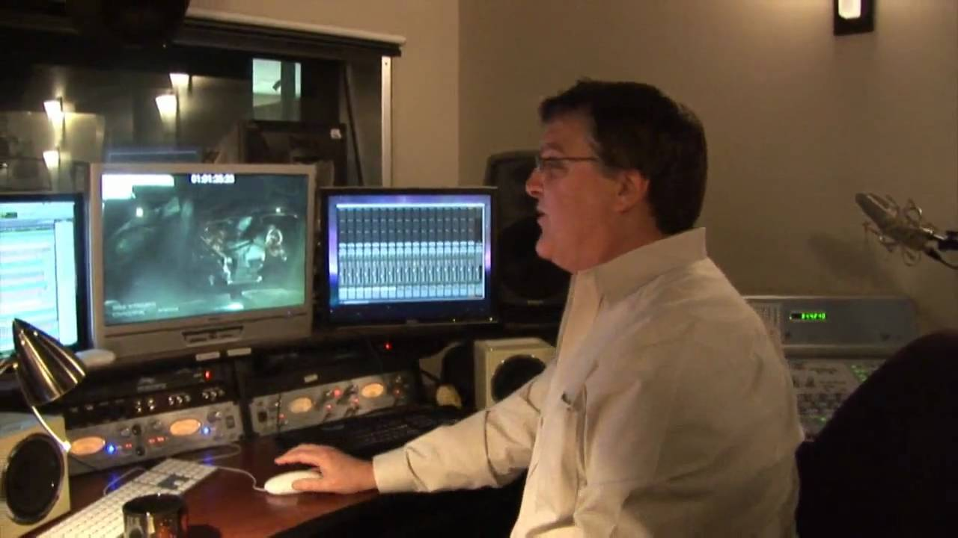](https://www.youtube.com/watch?v=fW5eq4G6WnA) [](http://martyodonnellmusic.com/)

# Contributors

Contributors are anyone who helps with a game without being involved with the company creating it such as by working for them or being paid by the company. Contributors can be: game testers, backers which are people who have given the game developers money before release to help them make the game, game testers, forums containing bug reports to give information to the developers to help them fix the bug which improves the game and finally a contributor can be someone on YouTube doing a let’s play of a game which then inclines the viewer to purchase the game.

An example of a game which without contributors would never exist is Undertale as the game was funded by the craters profit and mainly by the website Kickstarter where many people donated money to the developers, so the game could be made and released to the public. From this I have learnt that contributors can be helpful with games even though they are not usually paid even if it is something simple like someone making a video about the game which they like that could make people want to buy the game which of course helps the developers out. Also, I have learnt that as contributors such as youtubers can help with advertising for the game you should allow people to make videos of people playing your game without suing them for copyright like Nintendo used to do with their games which they received a lot of criticism for.

[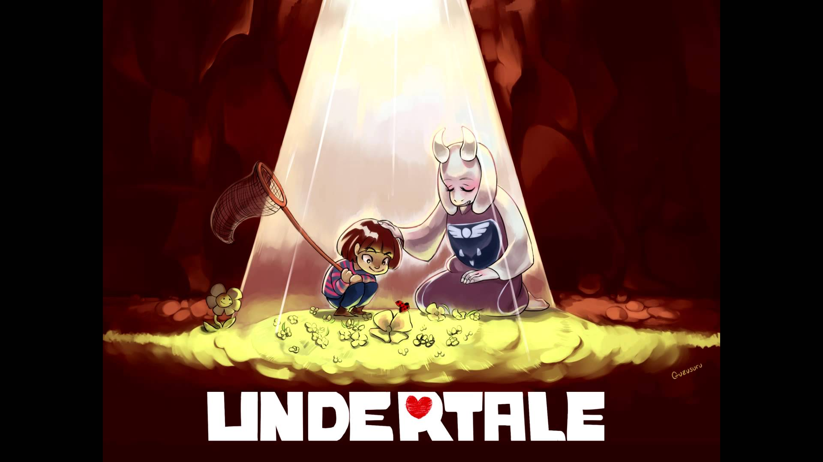](https://www.youtube.com/watch?v=bzeqvmQulO0)

[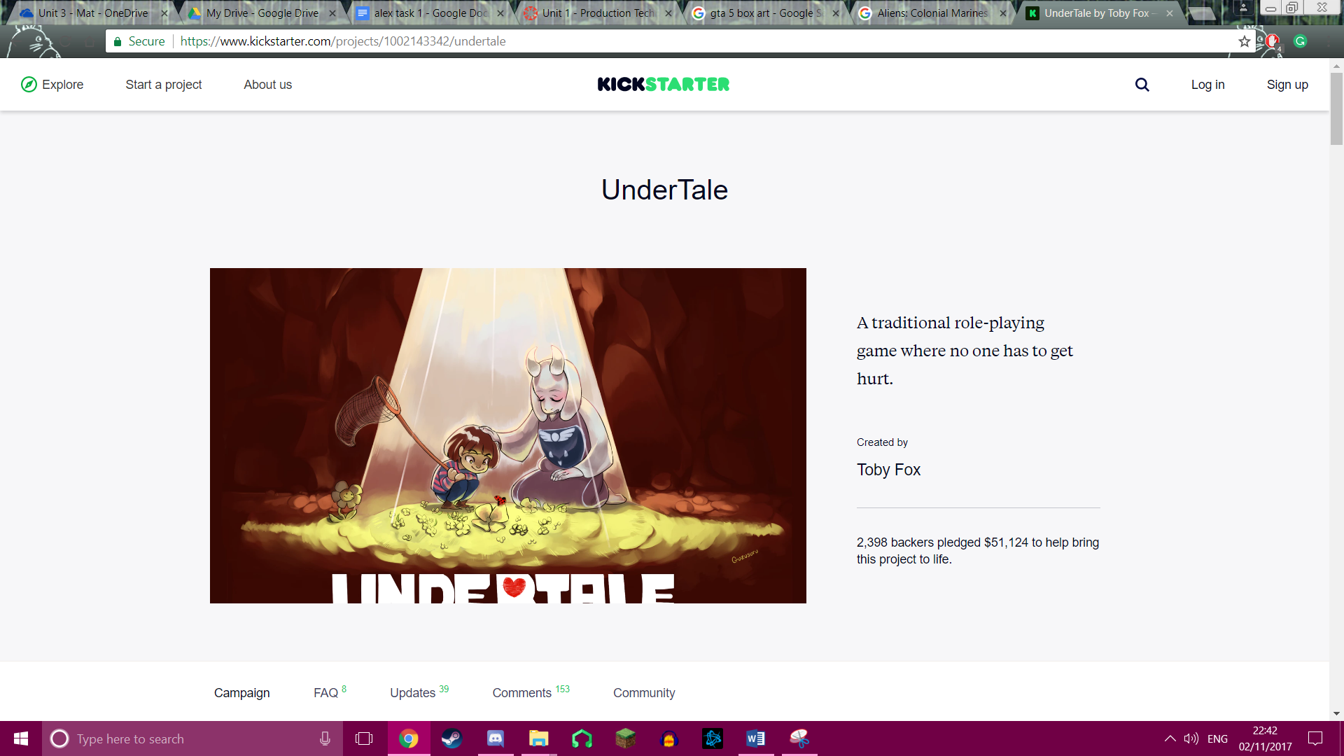](https://www.kickstarter.com/projects/1002143342/undertale)

# Location

Locations in games usually refer to where the game is set as if it was where the game was made it would just be the address of an average office or someone's bedroom. Although the location of a company's office is important and when deciding where to locate an office you should think about accessibility as if your workers must travel a long distance to get to work they be demotivated and tired as they would have to wake up earlier than usual decreasing workflow. Also, one of the most important things when deciding which office to go for is the price as if you will struggle to afford it there is no point of even trying to own or rent the place.

An example of locations used in video games is with the franchise Assassins Creed as each game in the series is based on a different historical event in time which of course means the games contain different places in the world. Especially with the game Assassins Creed Unity which is based on the French revolution, so Ubisoft would send the development team to go location spotting in France mainly Paris to find the perfect spot to have the playable character go in the game. From this I have learnt that the location of an office is important and that to really immerse the player in a game based in the real world you should go to that place in real life and location spot to find the best place to base the game off to make the game more realistic and enjoyable.

[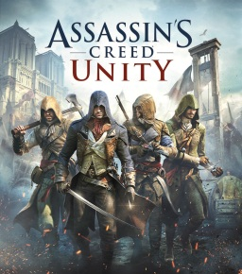](https://en.wikipedia.org/wiki/Assassin%27s_Creed_Unity)

# Codes of Practice

When producing a game there are regulations and codes of practice that must be constantly taken into consideration by the publishers and developers. Trademarks and copyright need to be looked at as well as if a developer is using someone else’s sound library they will have to ask the creator of the sounds if it is ok to use the sound in the game or if he must buy a license first. This is also needing to keep a game developer’s assets safe such as game characters, logo’s and box art which is protected by copyright. An example of this is if you were to make a game and use one of Nintendo’s characters such as Mario or Link without their permission they could sue you and take the game down. This has happened previously with a fan made Pokémon game called Pokémon Uranium but because the game called the pocket monsters Pokémon and called the catching devices Poke balls the game was copying the Pokémon franchise and invaded the copyright law and even though the game was free it was still taken down by Nintendo.

[](http://www.gameinformer.com/b/news/archive/2016/08/10/fans-come-together-to-create-the-original-unofficial-pok-233-mon-uranium.aspx)

Another regulation is including the PEGI rating system on the box art of your game. PEGI stands for Pan European Game Information and is a video game content rating system and are labels which appear on the front and back of a games packaging which informs the purchaser what ages the game is suitable for which can protect underaged children from violence and gore. The PEGI system has five different rating systems: 3, 7, 12, 16 and 18. An example of the PEGI rating system used is with the game GTA V (5) from this you can see that the age rating 18 can clearly be seen on the front of the games box art and on the back, it shows that the game contains bad language, drugs, violence and online multiplayer. From this I now know that if I make a game I will have to clearly show the game PEGI rating on the box art or I could get into trouble.

[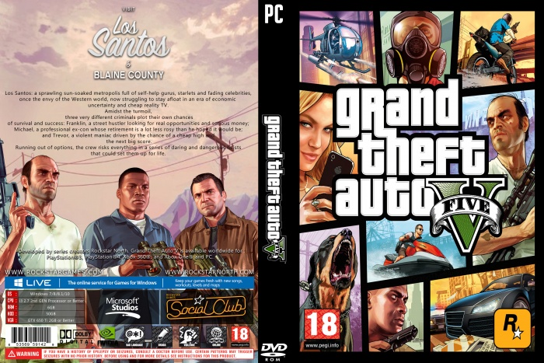](http://vgboxart.com/view/72052/grand-theft-auto-5-cover/)

PEGI 3:

This is rating is for games which contain comical violence such as Mario jumping on a Goomba. Also, the games should not contain any photo realistic characters getting hurt they have to be fantasy characters. The game should not scare the children playing and not contain any profanities.

http://www.pegi.info/en/index/id/33/media/img/320.gif

PEGI 7:

This is basically the PEGI 3 rating but with a bit more realistic violence and could contain some possibly scary scenes.

http://www.pegi.info/en/index/id/33/media/img/321.gif

PEGI 12:

This rating can contain little violence to photo realistic/human looking characters, minor swearing and a little bit of nudity such as a high skirt.

http://www.pegi.info/en/index/id/33/media/img/322.gif

PEGI 16:

This rating means the violence and or sexual activity has been raised to the point of realism and drug use can be shown in the game also criminal activities can be displayed and extreme bad language is prevalent. Games with this rating include Destiny 2, Uncharted 4 and W2K18.

http://www.pegi.info/en/index/id/33/media/img/323.gif

PEGI 18:

This rating is having the same qualities as PEGI 16 except with more revolting violence. A perfect example of this is with the game franchise Mortal Kombat.

http://www.pegi.info/en/index/id/33/media/img/324.gif

On the back of the packaging of a game also contains pictures dictating why a game is that specific PEGI rating. There are eight such pictures: violence, bad language, fear, drugs, sexual, discrimination, gambling and online gameplay with other people.

http://www.pegi.info/en/index/id/33/media/img/269.gif

Bad Language:  
Game contains profanities.

http://www.pegi.info/en/index/id/33/media/img/270.gif

Discrimination:  
Game contains depictions of, or material which may encourage, discrimination

http://www.pegi.info/en/index/id/33/media/img/271.gif

Drugs:  
Game shows drug use.

http://www.pegi.info/en/index/id/33/media/img/272.gif

Fear:  
Game may be frightening or scary for young children

http://www.pegi.info/en/index/id/33/media/img/273.gif

Gambling:  
Games that encourage or teach gambling

http://www.pegi.info/en/index/id/33/media/img/275.gif

Sex:  
Game depicts nudity and/or sexual behaviour or sexual references

http://www.pegi.info/en/index/id/33/media/img/276.gif

Violence:  
Game contains depictions of violence

http://www.pegi.info/en/index/id/33/media/img/274.gif

Online gameplay:  
Game can be played online

# Sources

<https://www.youtube.com/watch?v=CgcPM9TbhUY>

<https://en.wikipedia.org/wiki/Martin_O%27Donnell>

<https://twitter.com/DrKarateChop/status/733033325229658112/photo/1?ref_src=twsrc%5Etfw&ref_url=http%3A%2F%2Fwww.eurogamer.net%2Farticles%2F2016-05-19-homefront-the-revolution-acknowledges-its-own-troubled-development>

<http://www.eurogamer.net/articles/2016-05-19-homefront-the-revolution-acknowledges-its-own-troubled-development>

<https://www.youtube.com/watch?v=1cNJw8lACB8>

<https://www.youtube.com/watch?v=50v0En-U5Ck>

<https://kotaku.com/5986694/from-dream-to-disaster-the-story-of-aliens-colonial-marines>

<https://www.youtube.com/watch?v=Rew3rTDXTjs>

<https://en.wikipedia.org/wiki/List_of_most_expensive_video_games_to_develop>

<https://www.fool.com/investing/general/2013/09/28/gta-5-sales-hit-1-billion.aspx>

<https://www.forbes.com/sites/davidthier/2014/05/13/grand-theft-auto-5-has-sold-nearly-2-billion-at-retail/#231b71fa3d30>

<https://www.gamasutra.com/view/news/117731/Call_Of_Duty_Modern_Warfare_2_Hits_1_Billion.php>

<http://www.tvovermind.com/movies/15-great-low-budget-movies-made-relative-killing>

<https://www.youtube.com/watch?v=t4My4nOw4R4>

<http://www.the-numbers.com/movie/Kingsman-The-Secret-Service#tab=summary>

<http://www.the-numbers.com/movie/Kingsman-The-Golden-Circle#tab=summary>